National Institute of technology

Calicut



Department of Computer Science Engineering

Software Requirements Specification

Online Food Booking

(Version 2.0)

Submitted by

SURESH PATIDAR (M120357CA)

MANU G. KRISHNAN (M120353CA)

AMIT KUMAR SAH (M120369CA)

BITTU KUMAR SINGH (M120403CA)

Table of Contents

1. Introduction………………………………………………………………………………….............03

1.1 Purpose………………………………………………………………………......................03

1.2 Scope………………………………………………………………………………………………..03

1.3 Definition………………………………………………………………………………………….04

1.4 References………………………………………………………………………………………..04

1.5 Overview…………………………………………………………………………………………..05

1. Overall description…………………………………………………..………………………………05

2.1 Product perspective………………………………………………………………………….05

2.2 Product functions……………………………………………………………………………..06

2.3 User characteristics…………………………………………………………………………..14

2.4 Constraints………………………………………………………………………………………..14

2.5 Assumption and dependencies………………………………………………………….14

1. Specific requirements……………………………………………………………………………..14
   1. Functional requirements………………………………………………………………….14
   2. Non-functional requirements…………………………………………………………..20
   3. Performance requirements………………………………………………………………21
   4. External interfaces……………………………………………………………………………21
   5. Logical database requirement………………………………………………………….21
   6. Design constraints……………………………………………………………………………22
   7. Software system attributes………………………………………………………………22
2. Introduction

1.1 Purpose

The purpose of system is to provide solution to Online Food Booking for Mini Canteen. It will explain the purpose and features of the system, the interfaces of the system, what the system will do, the constraints under which it must operate and how the system will react to external stimuli. This system can increase the efficiency of daily food booking performed in canteen. The Customer can easily booking the food online. It will save the customer time. By this there will be no rush on the counter. It will be very flexible for the customer. It is intended for both customer and mini canteen members.

1.2 Scope

This software system will be an Online Food Booking for Mini Canteen of NIT Calicut. The system is designed to minimize the long queue on counter for order on peak time (rush hour). This system is designed to provide Food order to Mini Canteen through online from anywhere.

This system will facilitate an interface between a Customer and Mini Canteen Person. Simply, A User/Customer will have a login account through which he will able to select dishes from available menu. This system will accept their request and generate an order which will forward a message to Mini Canteen on their mobile, having Order Number, and list of items. After some time Mini Canteen Person will deliver the ordered Food to the respective person through their counter.

There is no instant requirement to pay the bill. This will have happen in advance, more precisely Customer credit amount to their account as an advance payment, whenever he/she buys Food item, total amount is deduced from their account. This system will also maintain transaction order into a relational database for future assistance.

1.3 Definition

1.3.1 Customer

The Person, who pay the advance money and demand the order for food,

1.3.2 Mini Canteen Manager

The person, who is manager of the Mini Canteen, will receive the order from the Customer through the SMS and forward this order to the staff member. He will also update the Customer information.

1.3.3 Staff Member

He is member of Mini Canteen. He delivers the food item to the Customer.

1.3.4 System

It acts as interface between the Customer and Manager. System takes order from Customer and forwards the order to Manager through SMS.

1.4 References

[1] IEEE std 830-1998 IEEE Recommended practice for Software Requirements Specification.

[2] <http://techwhirl.com/writing-software-requirements-specifications>

[3] <http://www.microtoolsinc.com/Howsrs.php>

1.5 Overview

The next chapter, the Overall Description section, of this document gives an overview of the functionality of the product. It describes the informal requirements and is used to establish a context for the technical requirements specification in the next chapter.

The third chapter, Requirements Specification section, of this document is written primarily for the developers and describes in technical terms the details of the functionality of the product.

Both sections of the document describe the same software product in its entirety, but are intended for different audiences and thus use different language.

1. Overall Description

This section of the SRS describes the general factors that affect the product and its requirements.

2.1 Product Perspective

2.1.1 System Interface

Not applicable

2.1.2 User Interface

The system is web enabled application. The customer can interact with the system through internet.

2.1.3 Hardware Interface

Not applicable

2.1.4 Software Interface

Not applicable

2.1.5 Communication Interface

This system requires a Mobile Phone for communication interface.

2.1.6 Memory

Not applicable

2.1.7 Operations

1. The users login into the system as a customer or manager.

2. The customer place the order for item.

3. The system will generate the order number.

4. The manager receives the order number.

5. The staffs deliver the item to the customer.

6. The manager updates the customer information.

7. The customer can order the food item up to 10:00 p.m.

2.2 Product Function

The section outlines the use case for both Customer and Manager.

Overall System Environment

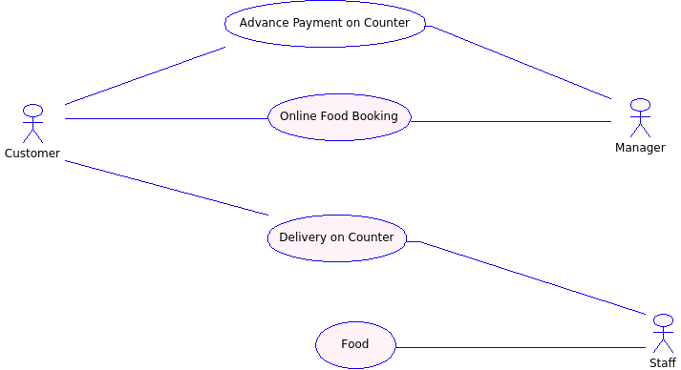

Figure 1.0

This system has three actors first one is a Customer, second one is Mini Canteen Manager and third one is staff member and one cooperating system. Any Customer and Manager can access this system through a login id. Customer can directly pay the bill in advance to the Manager. After receiving the advance payment the Manager updates Customer account.

2.2.1 Customer use case

Use case: Registration

Diagram:

C:\Users\USER\Desktop\SE SRS\use case\FigureTwo.png

Figure 2.0

Brief Description:

The new Customer accesses the website and creates an account.

Initial Step-by-Step Description:

Before this use case can be initialized, the Customer has already accessed the website.

1. The Customer fills the detail with Name, Roll number, Password, Email id, contact number, hostel, and security question.

2. After the Customer clicks on the submit button. The system will check roll number and password from the database.

3. If the roll no. and password matches with previous record. The system will generate a message like “You are already registered”.

4. Otherwise, system will store all the information about the Customer and generate a message like registered successfully.

5. After that Customer can communicate with the system by roll no. and password.

2.2.2 Use Case: Customer

Use Case: Food selection

Diagram:

C:\Users\USER\Desktop\SE SRS\use case\FigureThree.png

Figure 3.0

Brief Description:

The Customer accesses the website and selects Food from the menu for ordering.

Initial Step-by-Step Description:

1. The Customer login on the system.

2. If customer forgets to his password in this case we will be provide a recovery process.

3. Customer can edit/update to his profile.

4. The Customer selects food item from the available menu.

5. The system display choices to the Customer.

6. The Customer must ensure that they have enough credit in his account to place an order. Otherwise, system will generate a warning message to the Customer.

2.2.3 Use Case: System Operation

Diagram:

C:\Users\user\Desktop\renew\Figure 4.0.png

Figure 4.0

Initial Step-by-Step Description:

1. System will receive the order from Customer.

2. System will also update the information in database corresponding to the Customer for future assistant.

3. System will generate a message (SMS) containing the following information Customer roll number, list of selected food items, and delivery time. This message will be sent to the Manager.

2.2.4 Use Case: Payment Update

Diagram:

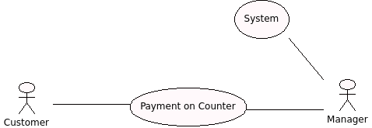

Figure 5.0

Brief Description:

The Customer goes to the counter of the Mini Canteen for advance payment. The Manager updates information corresponding to the Customer.

Step-by-Step Description:

1. The Customer goes to the counter and gives roll no., order no. to the manager.

2. The Manager accesses the website and selects detail about the Customer.

3. The Manager fills roll no. of Customer and submits the form.

4. System will show all information about the Customer.

5. The Customer pays in advance to the Manager.

6. The Manager updates his balance.

7. The system finally updates the current information of Customer.

2.2.5 Use Case: Order forward

Diagram:

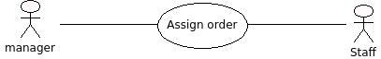

Figure 6.0

Brief Description:

The Manager forwards Customer order to the staff member.

Step-by-Step Description:

1. The Manager forwards order to the staff member with order number.

2.2.6 Use Case: Delivery

Diagram:

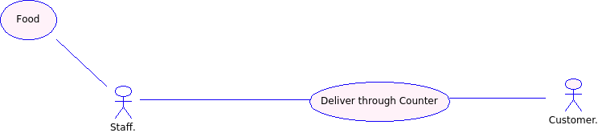

Figure 7.0

Brief Description:

The Customer will go to Mini Canteen and take the food item.

Step-by-Step Description:

1. The Customer will go to Mini Canteen within the appropriate time.

2. The Customer can demand counter for food parcel with order no. and roll no.

3. The staff checks delivery time according to the order number.

4. The staff delivers food parcel to the Customer.

2.2.7 Use Case: Manager

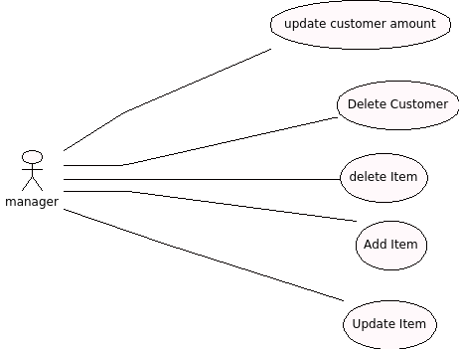

Figure 8.0

2.2.7.1 Use Case: Delete Customer

Brief Description:

Diagram:

C:\Users\USER\Desktop\SE SRS\use case 8.0\8.1.png

Figure 8.1

Step-by-step Description

1. The manager search list of Customers, who registered but not purchased food through online.

2. The manager deleted those customer accounts.

2.2.7.2 Use Case: Delete Item

Brief Description: The manager deletes the existing item from the database.

Diagram:

C:\Users\USER\Desktop\SE SRS\use case 8.0\8.2.png

Figure 8.2

Step-by-step Description

1. The manager login into the system.

2. The manager selects to delete item.

3. The system will show all previous items.

4. The manager selects the existing item.

5. The manager submits the form.

6. The system finally updates the database.

2.2.7.3 Use Case: Add Item

Brief Description: The manager adds the new item into the database.

Diagram:

C:\Users\USER\Desktop\SE SRS\use case 8.0\8.3.png

Figure 8.1

Step-by-step Description

1. The manager login into the system.
2. The manager selects to add item.
3. The system will show all previous items.
4. The manager adds the new item to the database with price.
5. The manager submits the form.
6. The system finally updates the database.

2.2.7.4 Use Case: Update Item

Brief Description: The manager updates the price of existing item.

Diagram:

C:\Users\USER\Desktop\SE SRS\use case 8.0\8.4.png

Figure 8.4

Step-by-step Description:

Before initiating this use case, the manager has already access the online food booking website.

1. The manager login into the system.

2. The manager selects to update price.

3. The system will show the entire existing item with price.

4. The manager selects the existing item for update the price.

5. The manager fills the new price of the item and submits the form.

6. The system finally updates the price of item into database.

2.3 User Characteristics

The customer is expected to have internet facility, whenever he want to order some food, he will login to the system and submit the order. The menu will be displayed in the main page, user simply select item, no. of quantity and submit the order, the system will generate a unique order number and given to the user. The user has to reach the mini canteen within the deliver time with the order number.

2.4 Constraints

-Not Applicable

2.5 Assumption and dependencies

* The system is required to save generated order.
* There is a requirement of internet
* System is supposed to be used by customer and mini canteen manager.
* Order is placed for only registered customer.
* Order of foods would be valid for one hour.

3.0 Specific Requirements

3.1 Functional Requirements

3.1.1 Registration

|  |  |
| --- | --- |
| **Use Case Name** | Registration |
| **XRef** | Section 2.2.1,Registration |
| **Trigger** | The New Customer assesses the online food booking Website |
| **Precondition** | The Web is displayed with grids for filling information |
| **Basic Path** | 1. The Customer fills the detailed with Name, Roll number, Password, Email.  2. After that Customer click on the submit button. The system will check the roll number and password from record account.  3. If the roll no. and password match with previous record then system will generate a message like “You are already registered”.  4. Otherwise, system will store information about Customer and generate a message like “Registered Successful”.  5. After that Customer can communicate with this system by roll no. and password. |
| **Post condition** | The customer successfully registered. |
| **Exception path** | Registered customer tries to register again. |

3.1.2 Food Selection

|  |  |
| --- | --- |
| **Use Case Name** | Food Selection |
| **XRef** | Section 2.2.2,Food Selection |
| **Trigger** | The Customer selects login link. |
| **Precondition** | The customer is on the web page where all food items are available. |
| **Basic Path** | 1. The Customer login on the system.  2. The Customer chooses the item from available items.  3. The system displays the choices to the Customer.  4. The Customer must ensure that they have enough credit in his account to place order. Otherwise, system will generate a warning message to the Customer. |
| **Post condition** | The item is selected. |

3.1.3 System Operation

|  |  |
| --- | --- |
| **Use Case Name** | System Operation |
| **XRef** | Section 2.2.3,System Operation |
| **Trigger** | System generate message. |
| **Precondition** | Order received. |
| **Basic Path** | 1. System will receive the order from Customer.  2. System will also update the information in database corresponding to the Customer for future assistant.  3. System will generate a message and send to the Manager through SMS with Customer roll number, list of selected food items, and delivery time. |
| **Post condition** | Message sent to the manager. |

3.1.4 Payment on Counter

|  |  |
| --- | --- |
| **Use Case Name** | Payment |
| **XRef** | Section 2.2.4,Upadate |
| **Trigger** | The manager updates the account in database of particular customer. |
| **Precondition** | The manager access the webpage for updating account. |
| **Basic Path** | 1. The Customer goes to the counter and give roll no. to the manager.  2. The Manager accesses the website and select detail option for showing the detail about Customer.  3. The Manager fills the roll no. of Customer and submits the form.  4. System will show all information about the Customer.  5. The Customer gives the advance rupees to the Manager.  6. The Manager updates his balance and submits.  7. The system finally updates the current information of Customer. |
| **Post Condition** | Update the account of customer |

3.1.5 Order Forward

|  |  |
| --- | --- |
| **Use Case Name** | Order Forward |
| **XRef** | 2.2.5, Order Forward |
| **Trigger** | The manager receives the order. |
| **Precondition** | The manager has mobile. |
| **Basic Path** | 1. The Manager receives the order through SMS. 2. The Manager forwards this order to the staff member. |
| **Post Condition** | The order forward to the staff member. |

3.1.6 Delivery on counter

|  |  |
| --- | --- |
| **Use Case Name** | Delivery on Counter |
| **XRef** | 2.2.6,Delivery |
| **Trigger** | The customer takes item from mini canteen counter. |
| **Precondition** | The customer should reach on time. |
| **Basic Path** | 1. The Customer will go to Mini Canteen within the appropriate time.  2. The Customer demand for food parcel with order no. and roll no. to the counter.  3. The staff checks the delivery time according to the order number.  4. The staff deliver food parcel to the Customer. |
| **Post Condition** | The customer will receive ordered food. |

3.1.7.1 Delete Item

|  |  |
| --- | --- |
| **Use Case Name** | Delete Item |
| **XRef** | 2.2.7.2 Delete Item |
| **Trigger** | The manager selects to delete item from the database. |
| **Precondition** | The manager has accessed the delete item page. |
| **Basic Path** | 1. The manager login into the system. 2. The manager selects to delete item. 3. The system will show all previous items. 4. The manager deletes the existing item to the database. 5. The manager submits the form. 6. The system finally updates the database. |
| **Post condition** | The systems finally delete the existing item. |

3.1.7.2 Add Item

|  |  |
| --- | --- |
| **Use case Name** | Add Item |
| **XRef** | 2.2.7.3 Add Item |
| **Trigger** | The manager selects to add item to the database. |
| **Precondition** | The manager has accessed the add item page. |
| **Basic Path** | 1. The manager login into the system. 2. The manager selects to add item. 3. The system will show all previous items. 4. The manager adds the new item to the database. 5. The manager submits the form. 6. The system finally updates the database. |
| **Post condition** | The system finally adds the new item. |

3.1.7.3 Update Item

|  |  |
| --- | --- |
| **Use Case Name** | Update Item |
| **XRef** | 2.2.7.4 Update Item |
| **Trigger** | The manager selects to update price to the database. |
| **Precondition** | The manager has accessed the update price page. |
| **Basic Path** | 1. The manager login into the system.  2. The manager selects to update price.  3. The system will show the entire existing item with price.  4. The manager selects the existing item for update the price.  5. The manager fills the new price of the item and submits the form.  6. The system finally updates the price of item into database. |
| **Post condition** | The system finally updates the price of item. |

3.2 Non Functional Requirement

* When Customer wish to place order ,then he will be ensure that whatever he has selected item, those will be available.
* Customer will be ensured that he has sufficient amount to make order.
* Message must receive by the manager without any delay.
* If Customer doesn’t reach within the delivery time, the order has expired and reduce 10% amount of given order cost and manager will be update Customer account.
* Customer can order the food item up to 10:00 pm.

3.3 Performance Requirements

-Not Applicable

3.4 External Interface Requirements

The external interface will be a message service provider. The message service provider work as message provider gateway between system and Manager. The system generate order send to Mini Canteen mobile as a message containing order number, list of item and delivery time. The message provider send message to Customer and Manager on their mobile number detail maintain by the purposed system.

There is no extra charge for message neither collect from Mini Canteen or Customer. This is also web portal to send message from site to mobile phone.

3.5 Logical database Requirements

The logical database requirements include the retention of the following data elements. This list is not a complete list and is designed as a starting point for development.

Registration System

* Customer name
* Customer Roll number
* Customer mobile number
* Customer email id

Food services

* Food
* Food Price
* Food Quantity

Customer Information

* Customer name
* Customer Roll number
* Customer Account Balance

3.6 Design constraints

The system will be developed using HTML, CSS, Java Script, PHP and a MYSQL database.

3.7 Software System Attribute

3.7.1 Reliability

Specify the factors required to establish the required reliability of the software system at time of delivery.

3.7.2 Availability

The system will be available all times, but customer can place order upto 10p.m.

3.7.3 Security

The server on which the online food booking resides will have its own security to prevent unauthorized *write*/*delete* access. There is no restriction on *read* access.

The Manager and customer will be able to log in to the On line food booking System. The manager has authorization to update the customer information. The customer can access the system only for placing the order and seeing the information about mini canteen.

3.7.4 Maintainability

This system can easily maintain by the manager.

3.7.5 Portability

-Not Applicable

4.0 Supporting Information

-Not Applicable